Practical 2

**Aim** : To Implement WordCount problem using Hadoop MapReduce in Eclips.

**Step** 1 : Run your cloudera system. Open Eclipse.

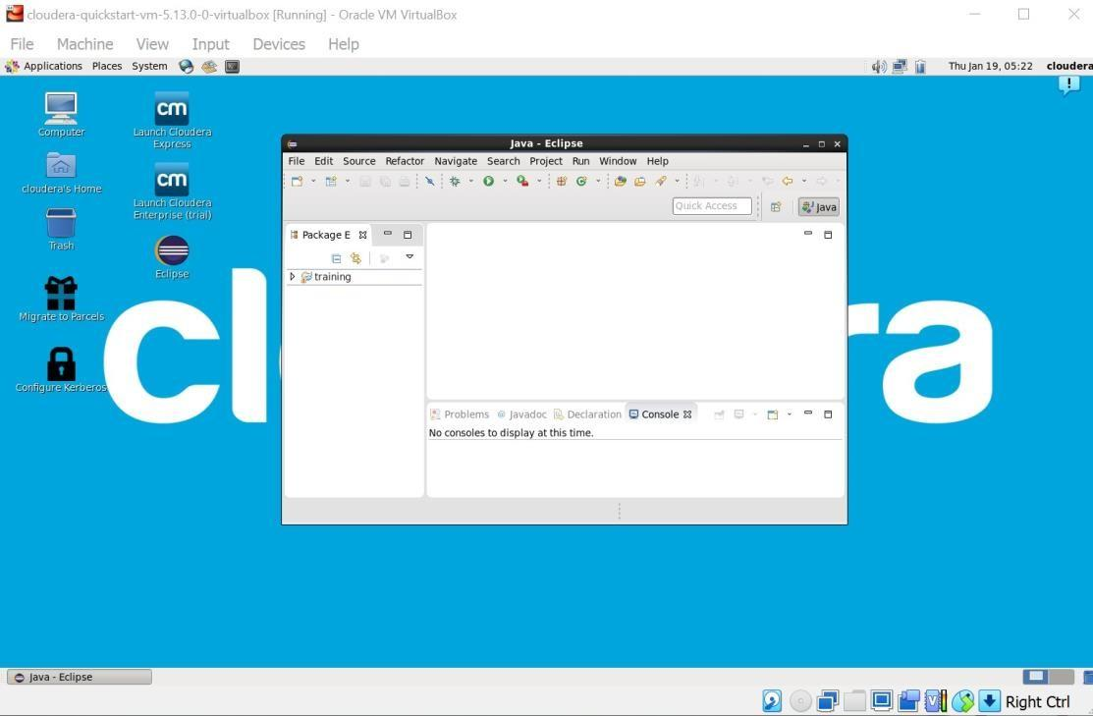

**Step 2** : Click on File > New > java project. Give Project Name (“WordCount”).

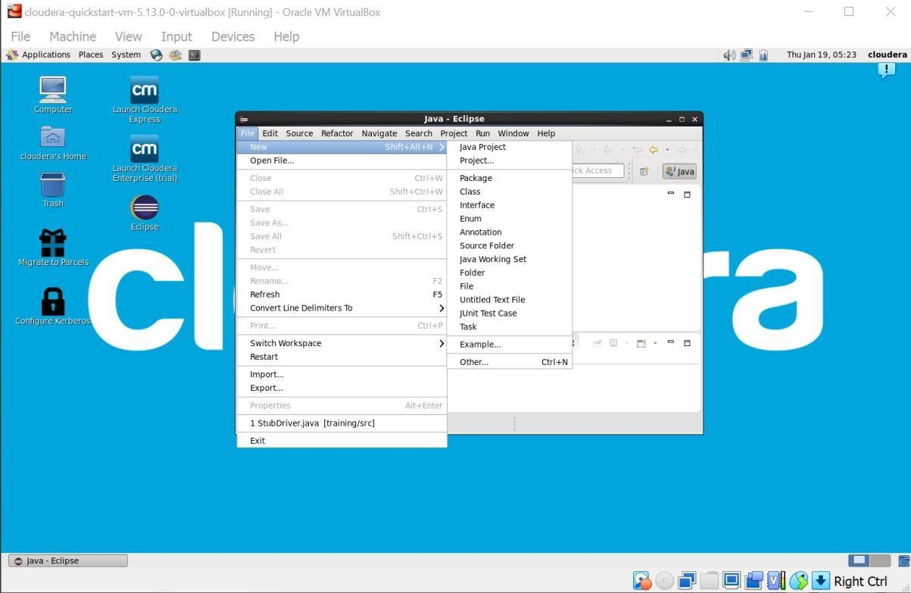

**Step 3** : Click on Libraries tab. Then click on Add External JARs… Tab To add Hadoop Libraries.

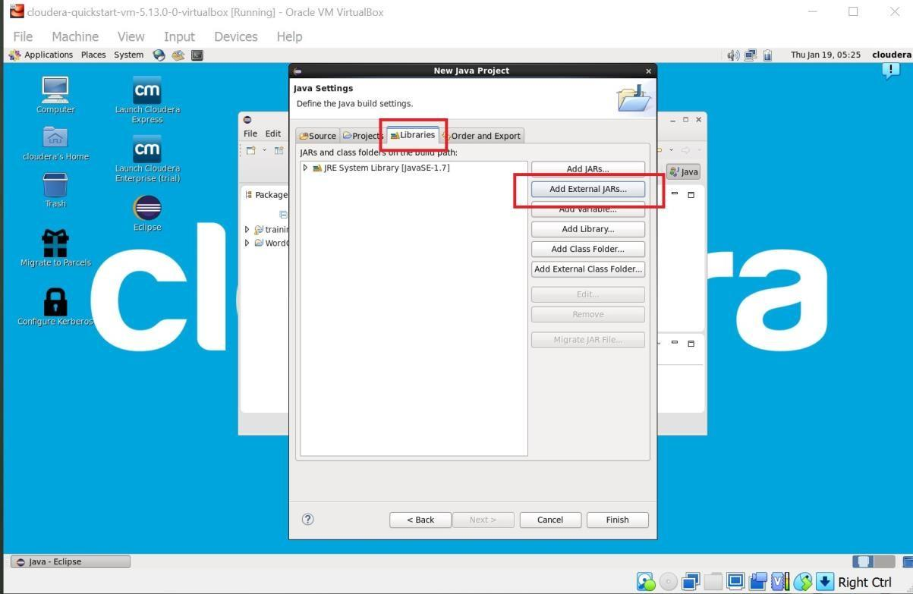

**Step 4** : Follow this steps : Click on File System -> usr -> lib -> hadoop (Select all the libraries (JAR files) -> Click OK.

Again Click on Add External JARs… -> client -> select all jar files -> ok -> Finish.

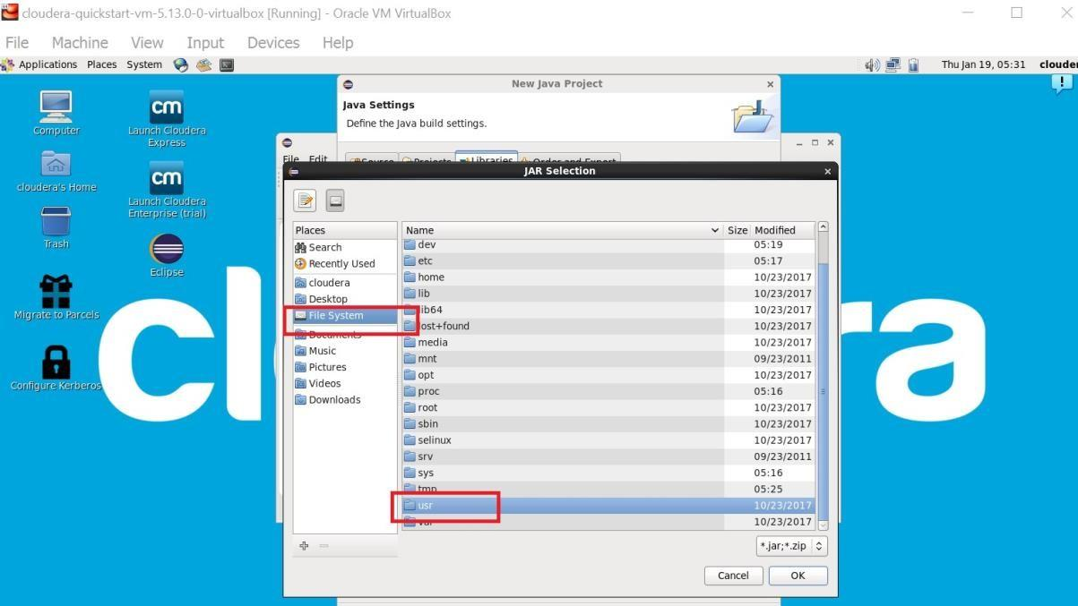

**Step : 5**

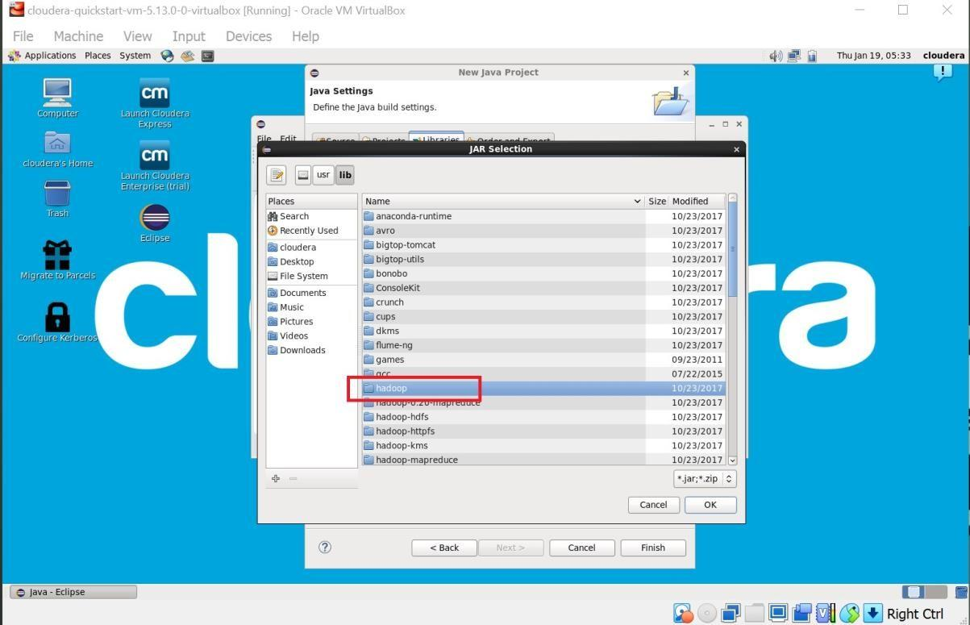

**Step : 6**

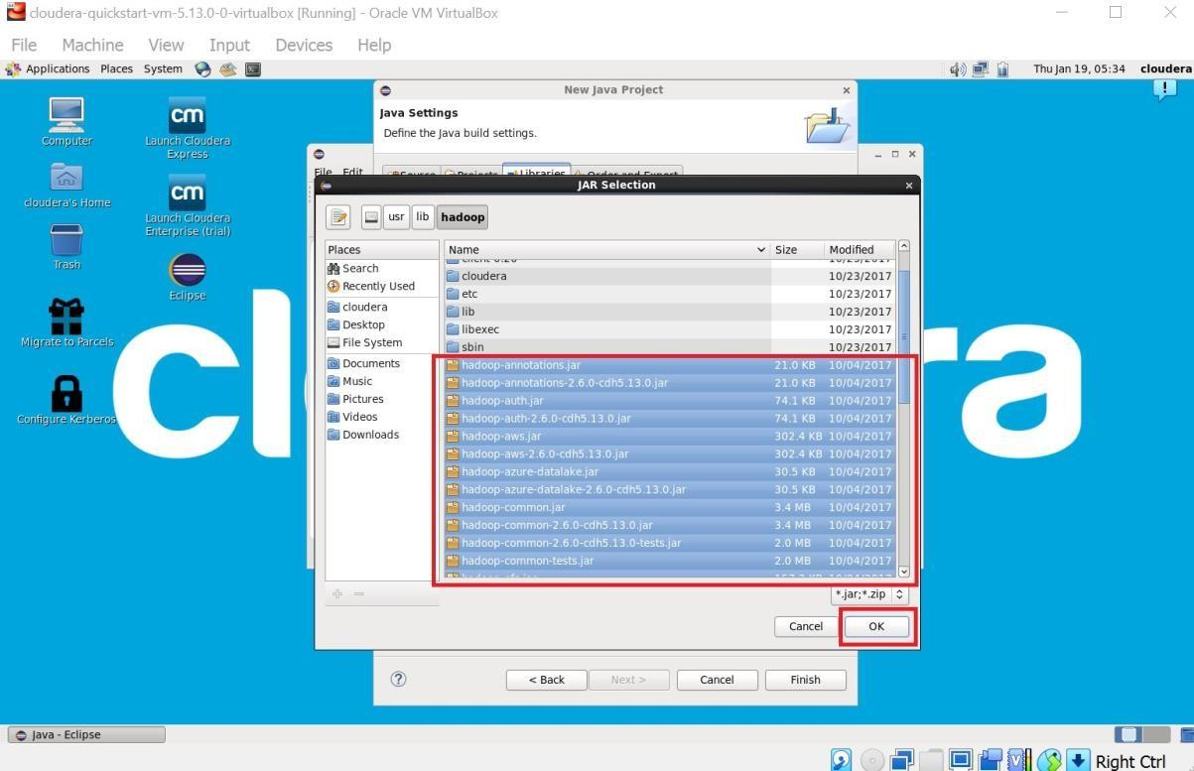

**Step : 7**

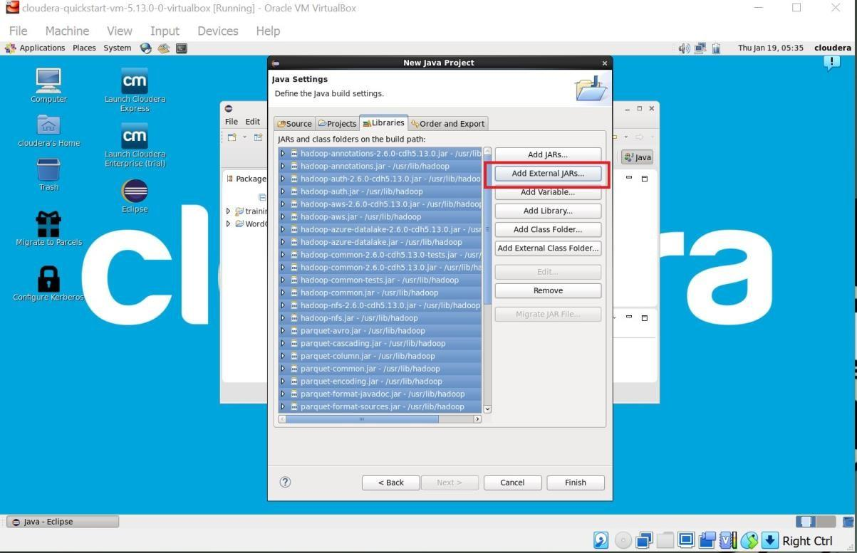

**Step : 8**

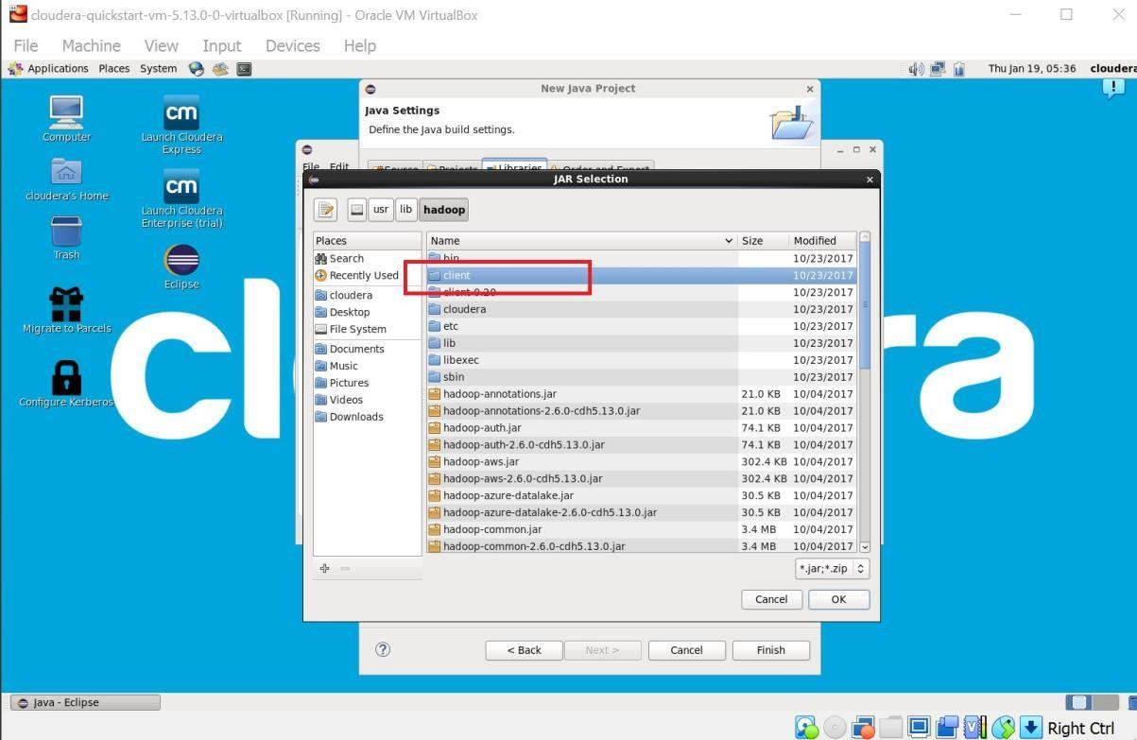

**Step : 9**

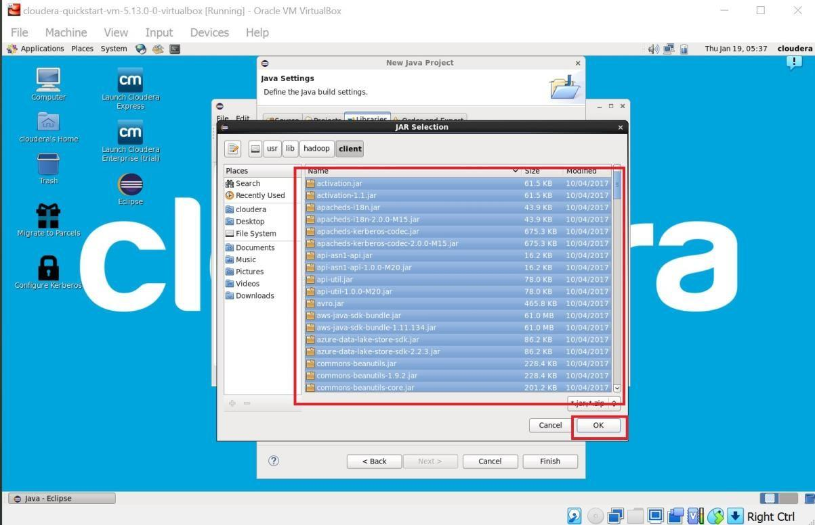

**Step : 10**

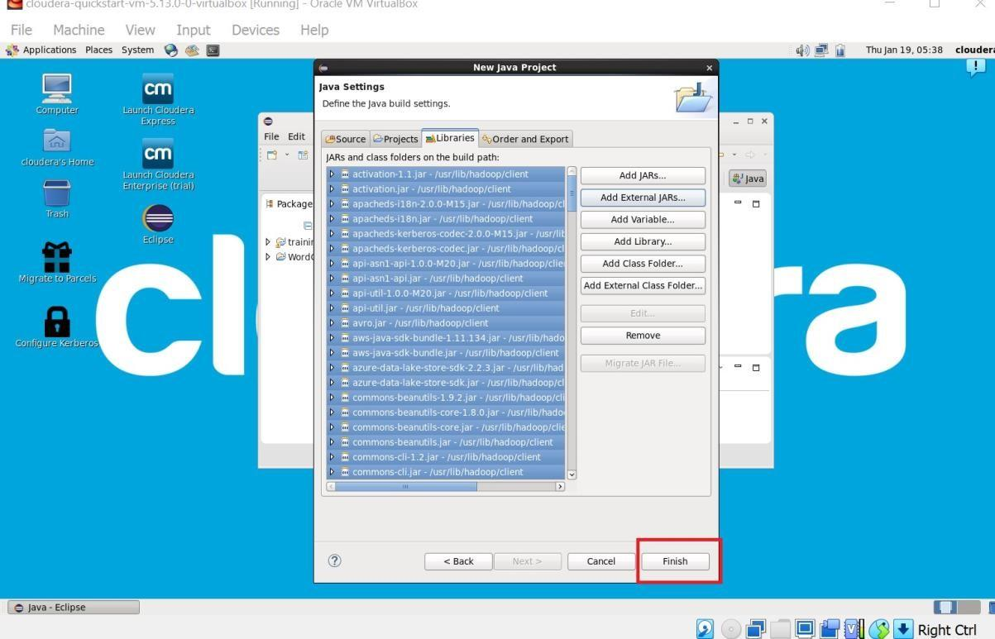

**Step 11** : Now you will see project name “WordCount” on sidebar. Right Click on Project name “WordCount” -> New -> class.

For package write name “WordCloud” -> Finish.

WordCount.java window will pop up.

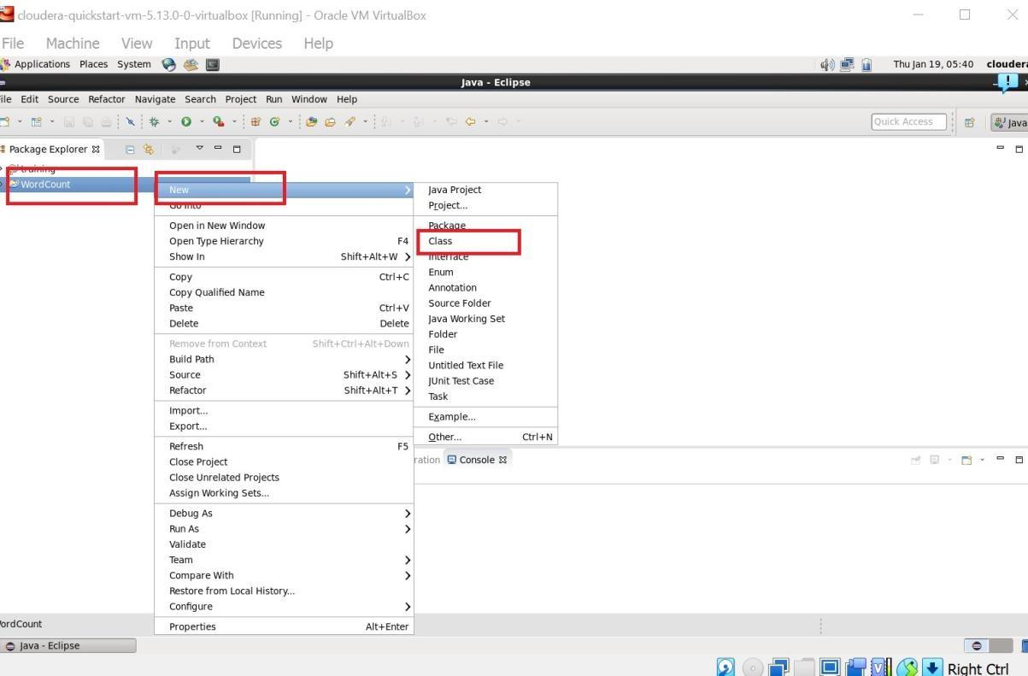

**Step : 12** 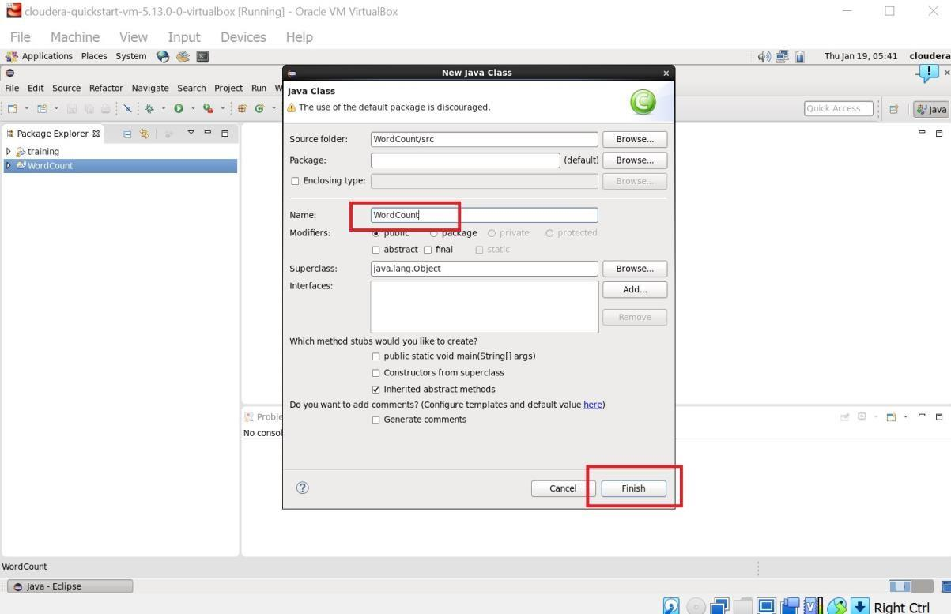

**Step 13** : Write your code in window(WordCount.java).

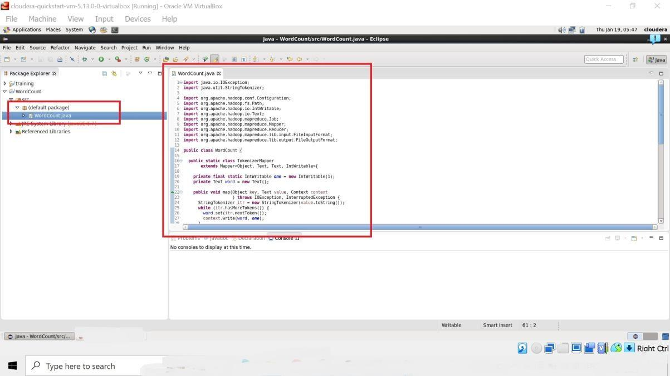

**Step 14 :** Right Click on the project name

WordCount -> Export -> Java -> JAR File -> Next -> For select the export destination for JAR file:

browse -> Name : WordCount.jar -> save in folder -> cloudera -> Finish -> OK

(** I used “WordCloud.jar” here)

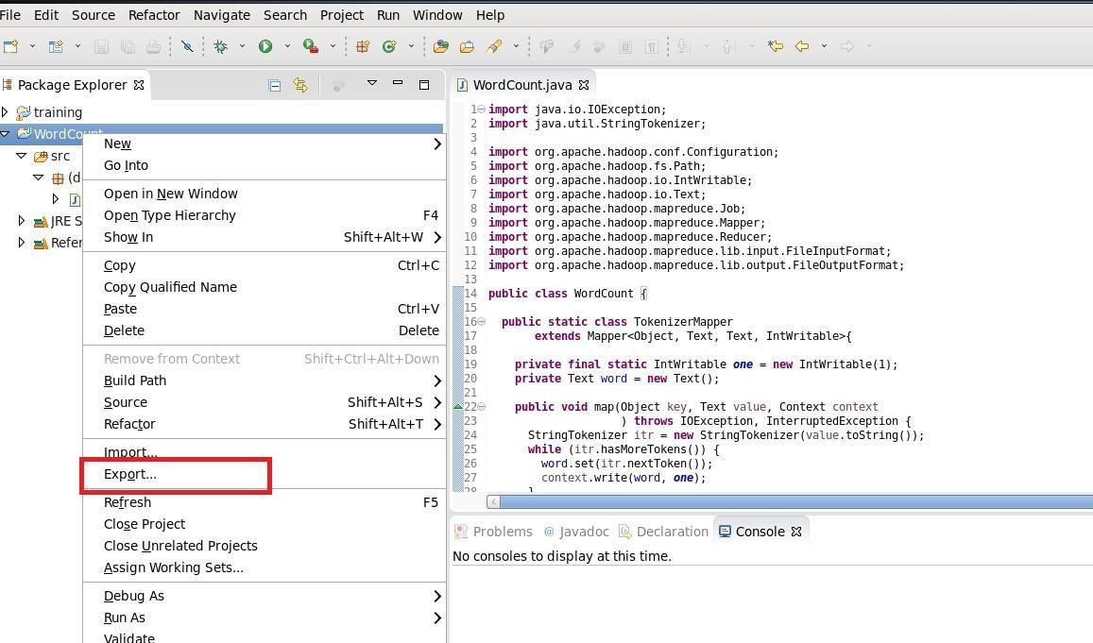

**Step : 15**

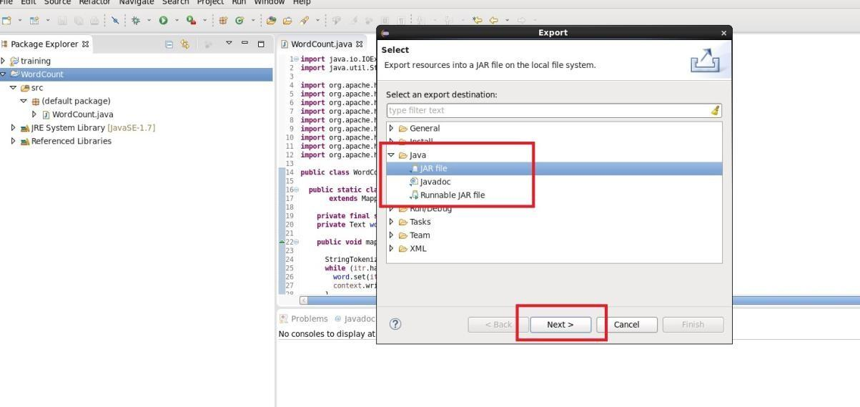

**Step : 16**

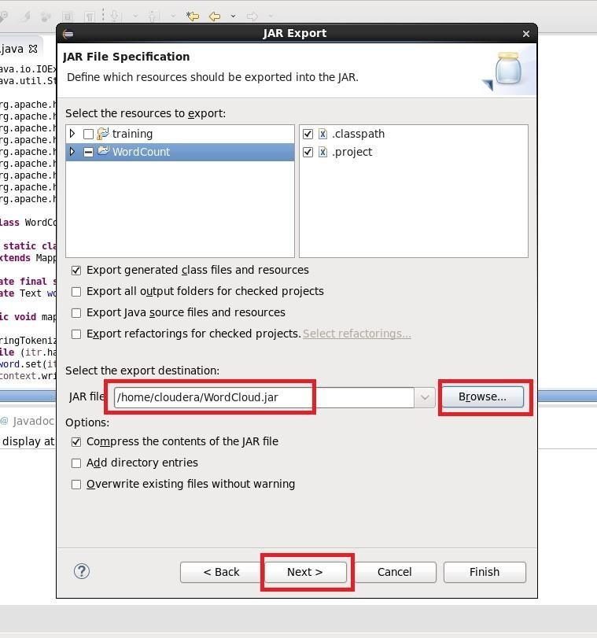

Step 17 : Now open terminal . follow this commands.

[cloudera@quickstart ~]$ ls cloudera-manager cm_api.py Desktop Documents Downloads eclipse enterprise-deployment.json expressdeployment.json kerberos lib

Music parcels Pictures Public Templates Videos WordCloud.jar Workspace

[cloudera@quickstart ~]$ pwd

/home/cloudera

[cloudera@quickstart ~]$ gedit abc.txt [cloudera@quickstart ~]$ cat abc.txt hi my name is Aman. my college name is R J College.

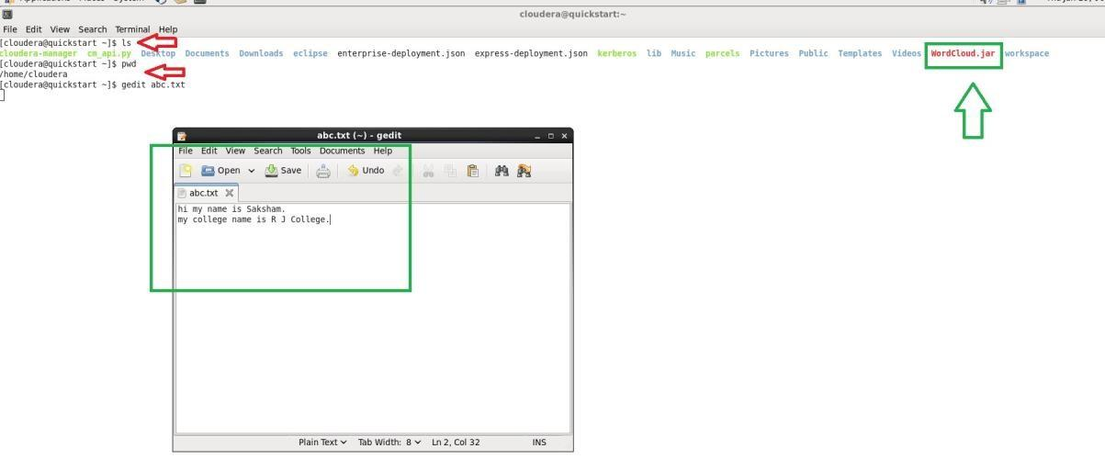

**Step 18 :**

[cloudera@quickstart ~]$ hdfs dfs -ls / Found 6 items drwxrwxrwx - hdfs supergroup 0 2017-10-23 09:15 /benchmarks drwxr-xr-x - hbase supergroup 0 2023-01-19 05:20 /hbase drwxr-xr-x - solr solr 0 2017-10-23 09:18 /solr drwxrwxrwt - hdfs supergroup

0 2023-01-19 05:20 /tmp drwxr-xr-x - hdfs supergroup 0 2017-

10-23 09:17 /user drwxr-xr-x - hdfs supergroup 0 2017-10-23 09:17 /var

[cloudera@quickstart ~]$ hdfs dfs -mkdir /inputdir

[cloudera@quickstart ~]$ hdfs dfs -ls / Found 7 items drwxrwxrwx - hdfs supergroup 0 2017-10-23 09:15 /benchmarks drwxr-xr-x - hbase supergroup 0 2023-01-19 05:20 /hbase drwxr-xr-x - cloudera

supergroup 0 2023-01-19 06:04 /inputdir drwxr-xr-x - solr solr

0 2017-10-23 09:18 /solr drwxrwxrwt - hdfs supergroup 0 2023-

# 01-19 05:20 /tmp drwxr-xr-x - hdfs supergroup 0 2017-10-23

09:17 /user drwxr-xr-x - hdfs supergroup 0 2017-10-23 09:17 /var

[cloudera@quickstart ~]$ hdfs dfs -put /home/cloudera/abc.txt /inputdir/

[cloudera@quickstart ~]$ hdfs dfs -ls /inputdir

Found 1 items

-rw-r--r-- 1 cloudera supergroup 55 2023-01-19 06:05 /inputdir/abc.txt

[cloudera@quickstart ~]$ hdfs dfs -cat /inputdir/abc.txt my name is Aman. my college name is R J College.

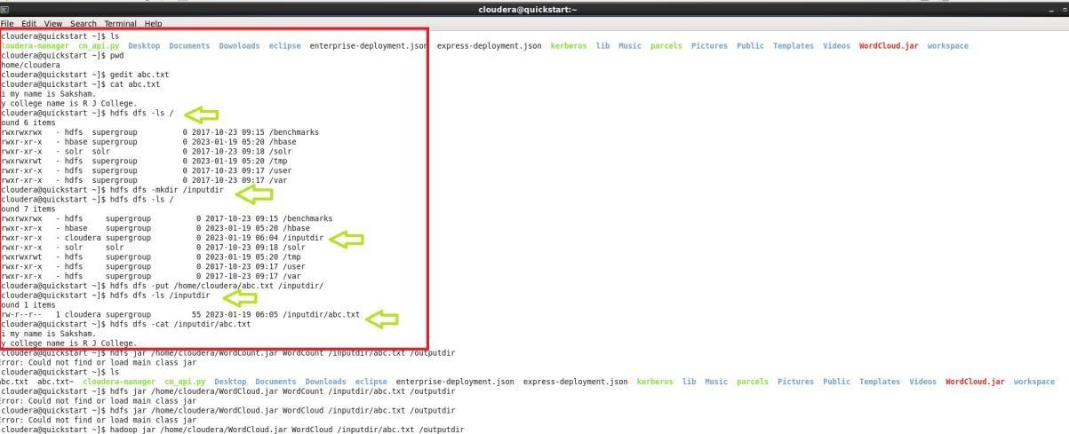

**Step 19 :**

[cloudera@quickstart ~]$ hadoop jar /home/cloudera/WordCloud.jar WordCount

/inputdir/abc.txt /outputdir It will Start executing the program

**executing the program.**

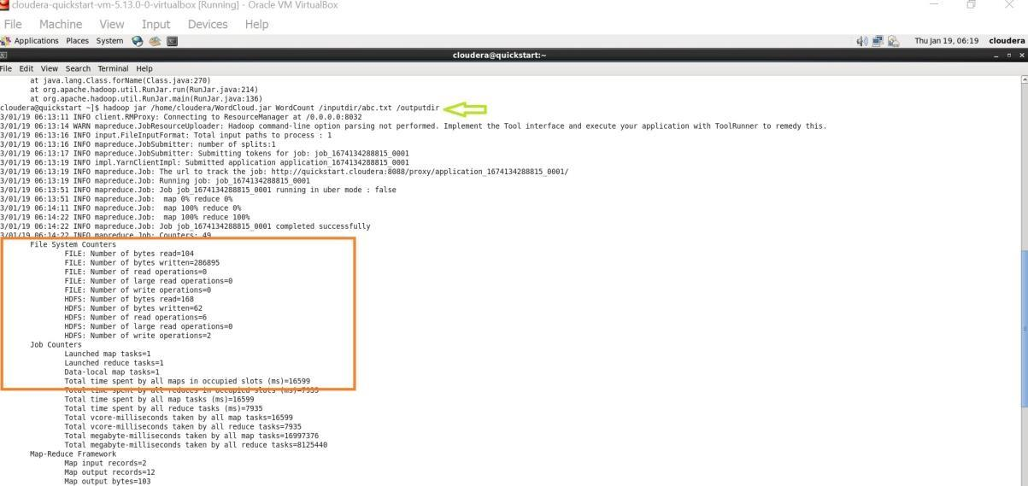

**Step 20 :**

[cloudera@quickstart ~]$ hdfs dfs -ls / Found 8 items drwxrwxrwx - hdfs supergroup 0 2017-10-23 09:15 /benchmarks drwxr-xr-x - hbase supergroup 0 2023-01-19 05:20 /hbase drwxr-xr-x - cloudera supergroup 0 2023-01-19 06:05 /inputdir drwxr-xr-x - cloudera

supergroup 0 2023-01-19 06:14 /outputdir drwxr-xr-x - solr solr

0 2017-10-23 09:18 /solr drwxrwxrwt - hdfs supergroup 0 2023-

01-19 05:20 /tmp drwxr-xr-x - hdfs supergroup 0 2017-10-23

09:17 /user drwxr-xr-x - hdfs supergroup 0 2017-10-23 09:17 /var

[cloudera@quickstart ~]$ hdfs dfs -ls /outputdir

Found 2 items

-rw-r--r-- 1 cloudera supergroup 0 2023-01-19 06:14 /outputdir/_SUCCESS -rw-r-r-- 1 cloudera supergroup 62 2023-01-19 06:14 /outputdir/part-r-00000

**Final Output :**

[cloudera@quickstart ~]$ hdfs dfs -cat /outputdir/part-r-00000

College. 1

J 1

R 1

Aman. 1 college 1 hi 1 is 2 my 2 name 2

# [cloudera@quickstart ~]$

